
https://atlas.cid.harvard.edu/

Optimal Industry Development Strategy Using Economic and Product Complexity

Portugal

─
The Economic Complexity Lab - Columbia University
Alexandra Garcia, Kelly Mi, Margarita Demkina, Allison Lin, Helena Yang, Jane Zhang, Daniel Xu, Ryo Shibata, Navia Zhang, Haoxian Chen, Davepriyan Gunaratnam, Rohan Macherla, Ajit Akole, Shomik Ghose, Alex Wei-Liang Ku, Sannidhya Modi, Xilin Wang
Optimal Industry Development Strategy for Portugal

0. Executive Summary

In this report, we aim to uncover the economic path Portugal went through during the period from 2019 to 2023. Specifically, we dive into the topic through a macroeconomic overview of Portugal from the perspective of Gross Domestic Product (GDP) and Economic Complexity Index (ECI), which reflect countries’ production capability and production structure, respectively. We find that during the period of our interest, Portugal demonstrated a high level of economic growth with an average annual GDP growth rate of 6.2% between 2019 and 2023, with a similar economic complexity compared to other major developed economies.

The mixed progress during the period, we believe, can be partially explained through the analysis of the economic and product complexity structure of Portugal on the industry group level, as well as the stagnant macro and microeconomic strategies. The product classification system we adopt allows us to measure the realized industry development for various industry groups and to observe that Portugal progressed in developing most of its industries during the period while its developed counterparts and economies around the globe also adopted complex and progressive paths with variable degrees of success.

Based on our analysis of the opportunity gain and sensitivity analysis of major industry groups, Portugal could further its gains by prioritizing Precious Stones, Weapons, and Energy, Drilling and Mining products in 2023. We further note that Portugal has a slightly mismatched development strategy that indicates a high level (compared to other developed countries) of structural optimality on the complexity level, having an adjusted of around 82.9% in 2023. Since a significant positive correlation exists between GDP growth and the structural optimality index of an economy as we define and calculate, Portugal indeed has an optimal growth experience as compared with fast-growing economies both on a regional scale and on a global scale and has the potential to further its economic gains through industrial structure optimization as suggested in the paper.

The five years between 2019 and 2023 showed a significant improvement in Portugal's economic growth, boosting its position on the global scale. Its GDP recovered to above the pre-pandemic levels, and it saw a significant boost in the ECI, particularly compared to its peer countries. Its current strategy still has the viable potential upside to increase its performance and optimize its structure further.

1. Report Overview

In this report, we aim to uncover the economic path Portugal went through during the period from 2019 to 2023. Specifically, we dive into the topic through a macroeconomic overview of Portugal from the perspective of Gross Domestic Product (GDP) and Economic Complexity Index (ECI), which reflect countries’ production capability and production structure, respectively. We then analyze the industrial framework and changes of Portugal during the period based on quantitative measures such as the Product Complexity Index (PCI) and Product Family Complexity Index (PCI), followed by a detailed analysis of how such changes have matched with development strategies as quantitatively measured by opportunity gains on an industry-level. We conclude our report with macro-level results and predictions of Portugal, as deduced from regression models we have established on a global scale, which take into account countries’ stances in their product space.

2. Macroeconomic Results

2.1 GDP Ranking and Changes
Figure 1 shows the GDP levels for Portugal and its peer countries (Italy, Spain, and Greece) from 2019 to 2022. Similar to the other countries, Portugal displayed a drop in GDP from 2019 to 2020 because of the pandemic, with all GDPs rebounding in 2021. Over these four years, Portugal’s average annual GDP growth rate (6.2%) is mediocre, as Italy’s rate (5.19%), Spain’s (6.33%), and Greece’s rates (6.76%) are variable around Portugal’s level. It is notable that the GDP levels in Portugal and Greece almost evened out beginning 2020.

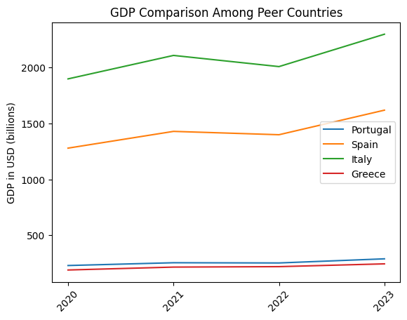
Figure 1. GDP Comparison Among Peer Countries (2019-2022)

2.2 ECI Ranking and Changes
The Economic Complexity Index (ECI), as defined by Ricardo Hausmann and Cesar Hidalgo in 2009 to explain the knowledge accumulated in a country's population, is illustrated in Figure 2.

The comparable countries saw a large change in ECI level between 2019 and 2020, with a slight decrease between 2020 and 2021. Portugal has seen a 129.53% decrease in its ECI, which is greater than Italy's (181.74% decrease) but less than Spain's (100.83% decrease), and Greece's (111.75% increase).

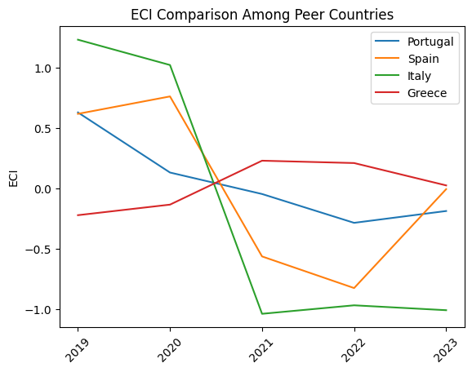
Figure 2. ECI Comparison Among Peer Countries (2019-2022)

Figure 3 offers a further comparison of GDP Growth and ECI over the time span from 2019 to 2022 for Portugal. The GDP growth during the period from 2019 to 2022 is accompanied by a similarly volatile increase in ECI. The GDP followed ECI trends, which can be interpreted as advancements in production. In order to provide a more concrete answer to why this has happened, we will dive into an analysis of Portugal’s production structure and its product space designs in the next few sections.

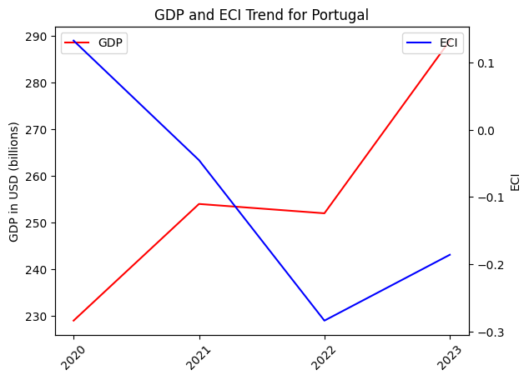
Figure 3. GDP Growth and ECI for Portugal (2019-2022)

3. Production Analysis

3.1 Product Categorization
Our main data source in this research is the UN Comtrade Website (https://comtrade.un.org), which provides us with valuable information on countries’ export values on an annual basis, including highly specific export data for more than 5000 categories of products. In order to have a holistic vision of the product space of a country, however, a level of categorization is required. Products in our data source are labeled from 010000-999999, with the first two digits representing a general category to which the product belongs. Based on the 99 categories extracted from the label, we further group the products into the 18 most widely-accepted industries, as summarized in Table 1.

Note that the High-complexity Products industry group is not a distinct industry but rather an aggregated industry that encompasses the most complicated products from the most technologically-advanced industries (as measured by PCI). This industry serves as an indicator for us to quantitatively evaluate how well a country has performed in developing cutting-edge technologies and closing its technological gap with advanced economies, which has become a topic of wide concern today. Indeed, when we rank the 18 categories based on PfCI (an equivalent concept of PCI as calculated based on the 18 categorized product groups), the High-complexity Products industry has the highest PfCI among all industry groups.

Category | Description
Animals and By-products | All kinds of meat, livestock and related by-products
Vegetables, Fruits and Plants | All kinds of plants, edible vegetables and fruits
Food and Preparations | Edible preparations, raw cooking materials and appliances
Clothing and Accessories | All kinds of fabrics, filament, clothing and accessories
Textiles | All kinds of textile articles and related products
Wood Products | Book, paper and other elementary products related to wood
Metals | Mining of all sorts of raw Metals
Refined and Processed Stones | Refined or processed stone products such as pearl and ceramics
Energy Drilling and Mining | Mining industry for energy, minerals, stone materials, etc.
Daily Instruments | Basic daily instruments such as sport requisites, timing and measuring tools
Raw Manufacturing | Basic products made from plastic, rubber, leather, etc.
Chemical Manufacturing | Advanced chemical products and pharmaceutical products
Chemicals | Raw chemical materials and by-products
Machinery and Construction | Machinery and mechanical appliances, including electrical equipment
Transportation | Vehicles and locomotives including aircraft, ship, railway, etc.
Weapons | Explosives, arms and ammunition
Services and Utilities | Financial, business, legal, communication, travel Services and Utilities, etc.
High-complexity Products | Agglomeration of advanced products with highest PCIs
Table 1. Categorization of Products

We further observe a positive correlation between the GDP and the export of High-complexity Products. A higher adjusted R-square exists between GDP and High-complexity Products exports, indicating that more successful economics, as measured by GDP, tend to be those that are capable of producing and exporting High-complexity Products as we define them. Tables 2a and 2b show the OLS results in a universe of 107 and 21 typical countries respectively.

 | High-complexity Products | Food and Preparations | Animals and By-products
Adj. R-squared | 0.075 | 0.006 | 0.002
F-statistic | 9.556 | 1.638 | 1.175
No. Observations | 107 | 107 | 107
Table 2a. OLS Regression Results of GDP against Percentage Volume of Exports

 | High-complexity Products | Food and Preparations | Animals and By-products
Adj. R-squared | 0.149 | 0.003 | -0.012
F-statistic | 4.510 | 1.059 | 0.7542
No. Observations | 21 | 21 | 21
Table 2b. OLS Regression Results of GDP against Volume of Percentage Exports

3.2 Realized Industry Development
Based on the aforementioned product categorization, we aim to capture Portugal's realized industry production strategy between 2019 and 2023 on a complexity level. In Hausmann and Hidalgo (2009), distance is defined to be a measure of how far a country is from a certain product, not in its product space. We extend this concept to all product groups and quantify how technically equipped a country is to develop the corresponding product groups. In other words, the shorter the distance between a country and a product group, the more capable a country is of developing products within that group. Defining this net distance change as the Realized Industry Development (RID), our export data allow us to calculate the RID of Portugal and the 18 product groups in 2023 through the difference, where a positive RID indicates a shortening of the distance (i.e., advancement of the industry), and a negative RID indicates the reverse. It is notable that all industries had positive RID in 2023.

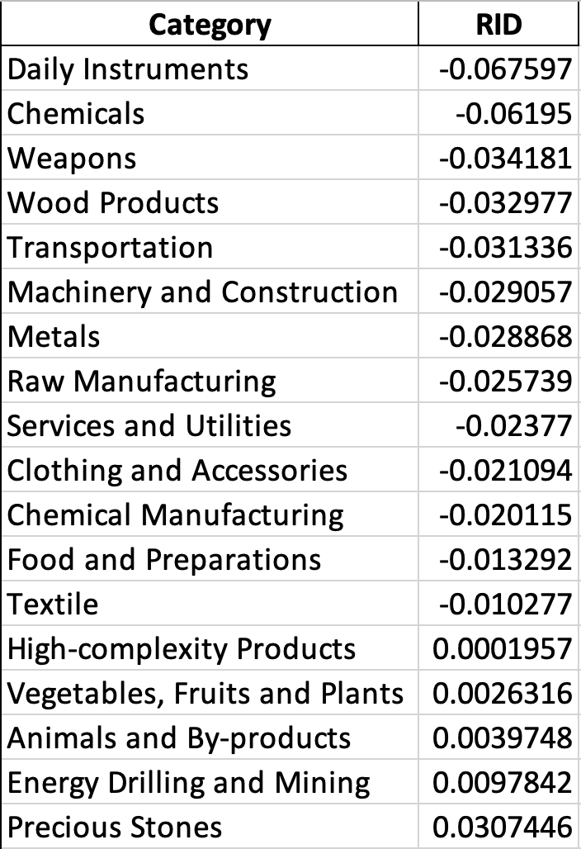
Table 3. Realized Industry Development (RID) of Portugal
3.3 Regional and Global Comparison
Table 4a below summarizes how the production strategy adopted by Portugal compares with selected leading economies in the world across different years, as measured in RID. Leading economies such as France, Greece, and Portugal gave a considerable level of attention to more advanced product groups such as Chemicals and Transportation in 2023.

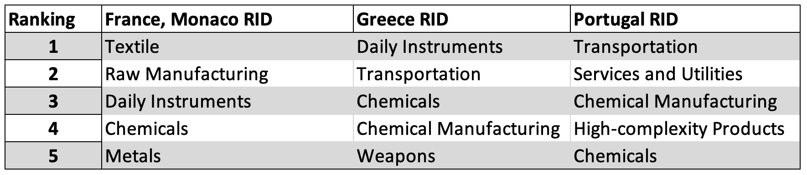
Table 4a. RID Comparison across Leading Economies (2023)

Table 4b further examines Portugal's development strategy against those of emerging economies on a global scale. Reasonably, emerging economies such as China and Singapore have devoted the majority of their efforts to intermediate industry groups.
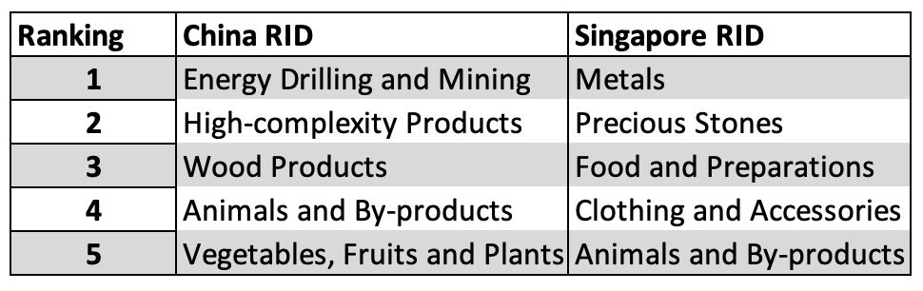
Table 4b. RID Comparison across Emerging Economies (2022)

4. Product Space Design

4.1 Suggested Development Vector
As outlined above, distance gives us an idea of how far each new product is from a country’s current mix of exports. As defined in Hausmann and Hidalgo (2009), distance is “the weighted proportion of products connected to goods p that country c is not exporting, i.e., MCP = 0.” Based on this definition, the distance between a country and any product that the country is currently exporting (i.e., the country is a significant exporter of the product as compared to the global average) is zero. Similarly, opportunity gain quantifies the contribution of a new product in terms of opening up the doors to more and more complex products. Intuitively, a product that a country is currently exporting (i.e., MCP = 1) has an opportunity gain of zero. An unreasonable investment in a certain product p would lead to a relative decrement in the export of more profitable products and therefore lead to a negative opportunity gain of product p. The opportunity gain is not the only estimator of a country’s level of economic development. However, among countries with comparable economic strength, those having higher ECI, or in other words, more reasonable economic structures are often in better shape.

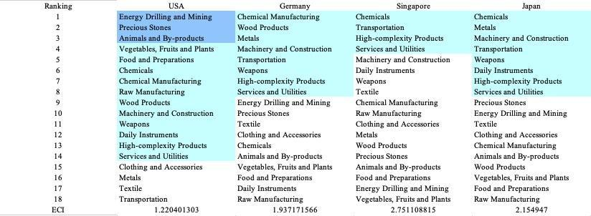
Table 5. Opportunity Gain Ranking on a Comparable Scale (2022)

We define the ranking of opportunity gain for a country c, as the Suggested Development Vector (SDV) of c. Table 5 summarizes how the SDV of the USA compares with a selected group of comparable economies in the world, with the industry groups ranked in decreasing order of significance.

Dark blue indicates positive opportunity gains, light blue indicates zero opportunity gains, and white indicates negative opportunity gains. Leading countries barely have any industries with positive opportunity gain. In other words, those countries are already in the most stable and efficient economic structure. Without the necessity of economic transition, those countries merely need to maintain a steady and balanced economic development. In contrast, developing countries have nearly half of industries with positive opportunity gain. The comparable countries share common interests in Energy Drilling and Mining and Animals and By-products industries. It can be concluded that Portugal shares some characteristics of developing countries, with a balanced economic structure that leans towards primary-level industries.


Table 6. SDV of Other Sample Countries (2019)

4.2 Budgeted Industry Development Strategy and Interpretation
The optimal budgeted industry development strategy aims to solve the most efficient allocations under the budgeted constraint of different situations of heuristic total export growth. In order to obtain such an allocation portfolio, we formulate an optimization problem as the following:



where k(x) is the second largest eigenvector of $M_{CC'}$ after adding $x$ to the original export vector, C is the country that we are interested in, P is the product space, B is the heuristic budget.

If we can solve this problem, then we can know what the largest ECI to which a country can improve. Accordingly, the optimal solution $x*$ that we obtain here is exactly our optimal allocation. However, the biggest problem is that the objective function is not convex. Therefore, we cannot apply the classical tools for convex optimization to this problem. In order to solve this problem, our idea is to use a greedy algorithm. The way that we apply the greedy algorithm is that firstly we separate the total budget into k equal parts, and then for the first equal part we try to search for the product that can optimize our objective function by iterating through each $p∈P$. After we find the optimal product p for this equal part, we add the amount back to the export value of this product p and update the ECI for this country. If we observe that ECI does not change after iterating all the products, then we can add up one more equal part to invest. Until we find there is an ECI increment, we add the amount now to that product. The equal rest parts can be done in the same way.

By definition, a greedy algorithm is a kind of local search algorithm that is possible to run into a local minimum. Therefore, for local search algorithms, one typical way to keep it away from the local minimum is to enhance the vision of the algorithm by looking more steps forward. In our setting, whenever we obtain an increment of ECI, we mark down the required amount of export growth. Simultaneously, we continue searching for the next ECI increment point, compare the ratios of these two possibilities and pick the largest one. The ratio is defined as the following:

where ${ECI}_{p}$ is just the ECI of the country after adding some amount of export increment to product $p$, which is exactly the amount that is able to make ECI change. Also, we can express it in the way of $||$$x_{p}-x_{0}$${||}_{1}$.

In this way, we can obtain a further sighted greedy algorithm. Also, the number of parts that we would like to separate the budget into also matters. In order to solve this problem, we added a stabilizer on top of the enhanced greedy algorithm by running the algorithm for different numbers of parts and selecting the portfolio with the largest ECI increment and most complex economic structure.

Besides, it is quite common that there is a surplus in the budget. To deal with the surplus, we just add it to the product which needs the least amount of dollars to make $M_{cp}$ = 1 (i.e., the smallest amount of required export increase).

Economic Panel
As stated above, the enhanced greedy algorithm is developed mainly for solving the optimal allocation strategy. In order to visualize this allocation, an economic panel is created, consisting of a pie chart, a line chart and a table. First, a pie chart is used to show the percentage of each product in the optimal portfolio. The number located in the center of the circle denotes the heuristic growth of total export, which is also our budget. Each category in the chart has a determined percentage of the allocated budget. The lines below the pie charts show how the ECI changes during the searching process of the greedy algorithm. Even though sometimes an increase of the export by 15% or 20% does not seem reasonable to developed countries, yet it can also give a sense of how a country should develop in the long term. Eventually, the graph in the end is just for numerical explanation for the pie charts.

Interpretation
For the purpose of a clear explanation of the line charts, we label all the products in Table 7. Please refer to this table when trying to understand the investment trajectories in the line charts.

Label | Product Names
1 | Animal and By-products
2 | Vegetables, Fruits and Plants
3 | Food and Preparations
4 | Energy Drilling and Mining
5 | Chemicals
6 | Chemical Manufacturing
7 | Raw Manufacturing
8 | Wood Products
9 | Clothing and Accessories
10 | Textile
11 | Metals
12 | Machinery and Construction
13 | Transportation
14 | Weapons
15 | Daily Instruments
16 | Precious Stones
17 | High-complexity Products
18 | Services and Utilities
Table 7. Products Labeling

Figure 4 shows an economic panel for Portugal in 2023. We can see that for different percentages of heuristic total export growth, the ECIs of Portugal actually have different increments.

For 2023, a 5 percent increase in export would emphasize High Complexity Products, followed by Precious Stones, then Machinery and Construction. For a 10 percent increase, Energy Drilling and Mining products are emphasized. For 15 and 20 percent export growth, the Weapons industry becomes more important although the diversity of product importance also increases. These strategies go in line with the suggested trajectories based on ECI. A more detailed numerical representation of the portfolio for Portugal is shown in Table 8.
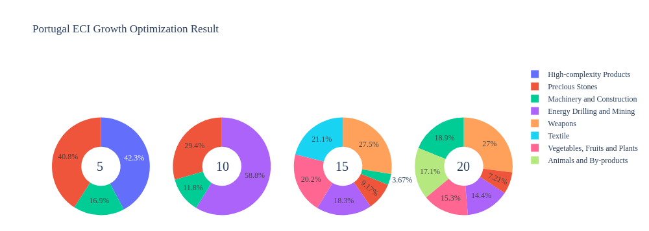

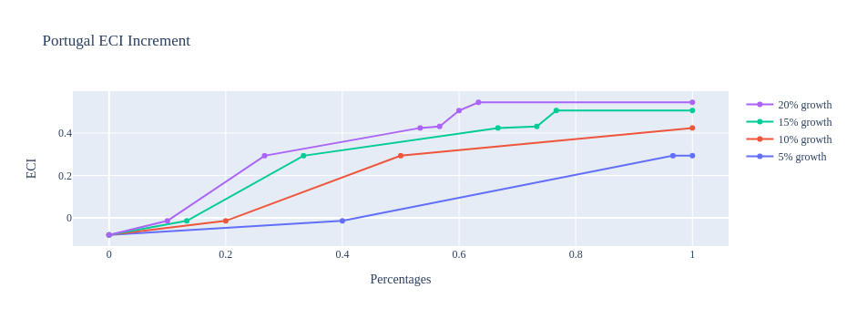
Figure 4. Greedy-Based ECI Improvement Results of Portugal with Different Budgets (2023)

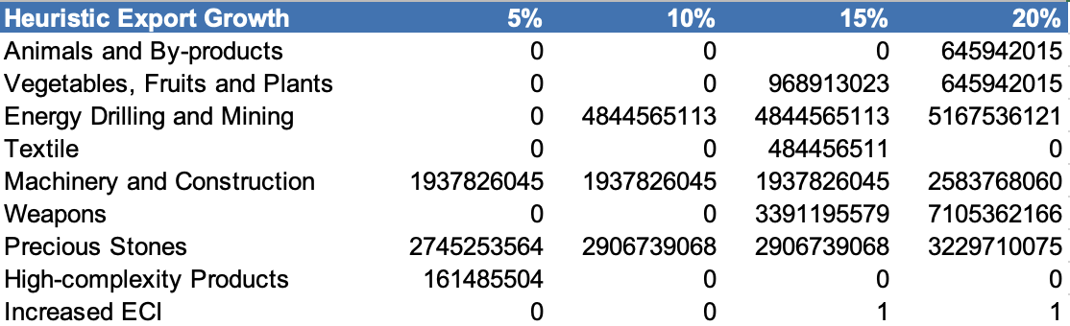
Table 8. Portfolio of Portugal (2023)

4.3 Sensitivity Analysis and Contingency Strategy
In the following section, our broad aim is to understand how sensitive Portugal is to changes in export in various industries. While the Economic Complexity Index has been shown to contain valuable information about the economic strength/capacity of a country, little has been said as to the stability of the measure itself. We seek to uncover the main drivers of stability under a country's ECI score and better understand longer-term projections for ECI growth. Additionally, gaining an intuition on the industries that are bolstering an economy and the industries that offer the greatest return per unit of investment is best done through visualization of industry-specific sensitivity. To this end, we have developed two categories of sensitivity analysis.
ECI Sensitivity Graph
First, in order to assess the effect particular industries have on each respective country, we developed ECI Sensitivity graphs (Figure 5). We use the shocking methodology to increment or decrement an industry’s export level by a certain percentage and recalculate the ECI, all else being equal. While freezing the export dynamics of the rest of the world and enacting an instantaneous shock in export for a particular industry and country may not reflect real-life dynamics, what it does offer us is an understanding of a country’s level of dependency on an industry in the context of ECI. The shocking is done in small percentage increments in order to smooth out the resulting curve. Additionally, a recurring theme one will see is that for most industries, a breaking point occurs where the ECI either jumps upwards or downwards, creating a hockey stick shape rather than a linear trend. While the inflection point may not be accurate in the context of real life, comparing the various inflection points across industries can give us valuable insight.

Figure 5. Sample ECI Sensitivity Graph (2018)
The graphs are formulated as follows. The first chart, Incremental ECI Sensitivity, shows positive shocking in which export numbers are shocked upwards per industry. The X-axis is in terms of percentage shock per current dollar value of export. The Y-axis is the recalculated ECI level post-shocking. The second chart, Decremental ECI Sensitivity, follows the same format except the X-axis represents negative shock. In other words, exports for each industry are decremented, and the ECI is accordingly recomputed.
4.3 Sensitivity Analysis Results and Interpretation
We examine Portugal's ECI Decremental and Incremental Sensitivity Charts for 2023. An increase in Energy Drilling and Mining will lead to the highest change in ECI, followed by Food and Preparations and High Complexity Products. For the negative shock cases, Metal becomes most impactful. The rest of the industries do not appear to have the same level of sensitivity.

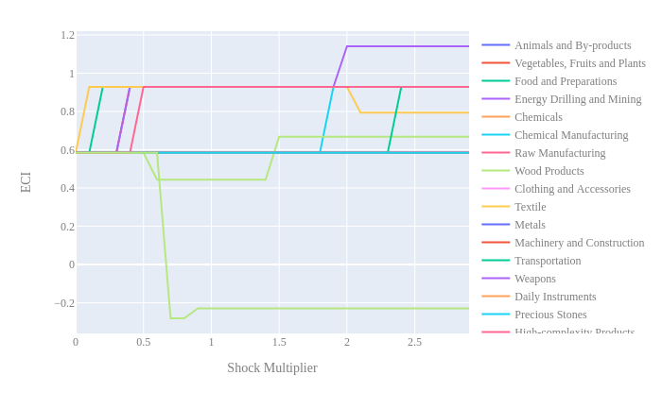
Figure 6a. Incremental ECI Sensitivity for Portugal (2023)
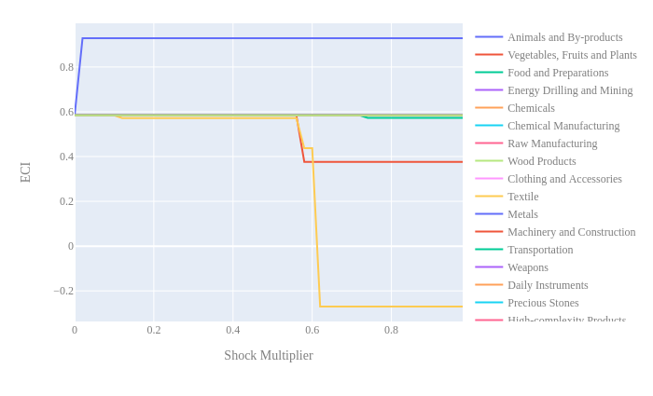
Figure 6b. Decremental ECI Sensitivity for Portugal (2023)

5. Macro-level Predictions

5.1 Structural Optimality Index
ECI sensitivity described in the section before has proven to be a significant factor in deciding the economic outcomes of countries. In order to quantitatively evaluate how effective our development strategies are and how deviations from the suggested developmental path will lead to suboptimal growth results, we define the measure – Structural Optimality Index (SOI) – on a country level as the Adjusted R-Square obtained from regressing the country’s realized industry development over the suggested development strategy. Both strategies are quantified in nature, with the realized development represented by increasing export in every major industry group and the suggested development strategy represented by the opportunity gains of developing the corresponding industry groups as calculated in previous sections. The adjusted R-square from the regression thus provides us with a quantified measure of how the development path adopted by the country has fitted with/differed from calculations on a complexity level.

After obtaining this measure for all countries in our database, we further regress countries’ five-year economic growth, which is defined as the percent increase in GDP (USD), over their SOI. Figure 9 illustrates the regression output, which shows a strong positive correlation between countries’ SOI and their five-year GDP growth. In other words, the more a country develops, as suggested by calculations on a complexity level, the better economic outcomes it achieves.

Table 14: OLS Regression Results
Dep. Variable: GDP | F-Statistic: 9.684
R²: 0.829 | Prob (F-Stat): 0.0896
Adj R²: 0.743 | No. Observations: 4
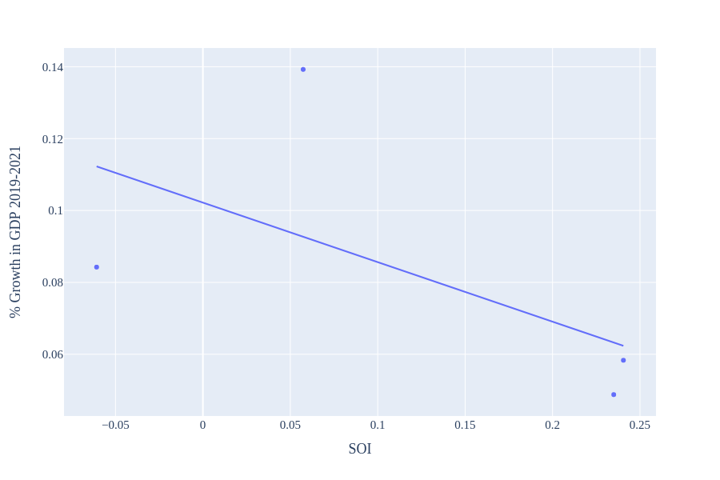
Figure 9. Regression of Five-Year GDP Growth over SOI (2013-2018)

5.2 SOI of Portugal and Its Implications
During the first examined period, Portugal, for instance, has a high level of structural optimality as compared with its developed peers. As the regression in Figure 10 suggests (the red curve represents export increase and the blue curve stands for opportunity gain of the corresponding industry), Portugal demonstrates a high level of correlation with the suggested developmental path, having an adjusted R-square of around 0.73123681.

For the 2019-2023 years, Portugal has a strong presence in the Energy Drilling and Mining and Raw Manufacturing industries. The Precious Stones industry presents a good opportunity for further investment as their opportunity gain is greater than their RID, while Raw Manufacturing has already surpassed its opportunity gain. It also could consider Metals, Textile, and Clothing and Accessories industries to improve its growth. Portugal has seen a growth in GDP over those four years, with an average growth of 6.20%.

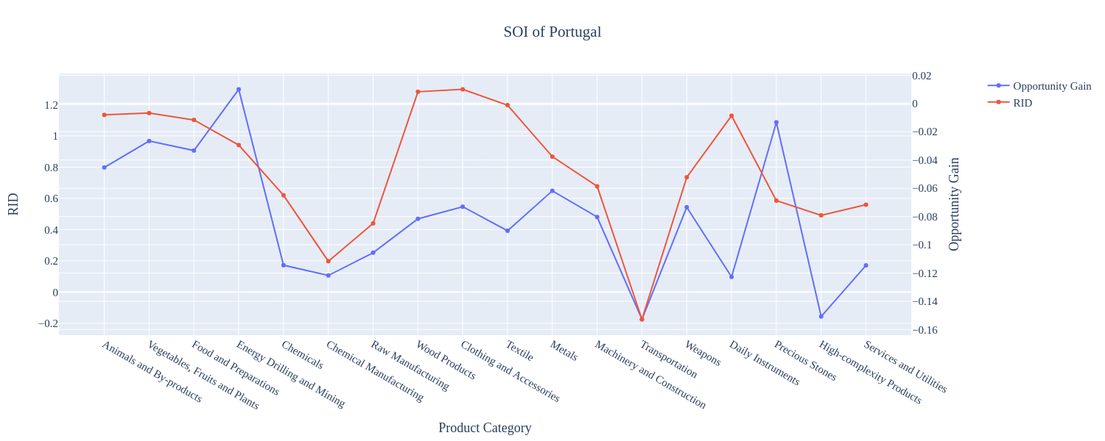
Figure 10. SOI of Portugal (2019-2023)

6. Concluding Remarks

In conclusion, Portugal has demonstrated a high level of economic growth in terms of annual GDP increase during the period from 2019-2023, concurrent with an increase in economic complexity as compared with major developed economies.

We believe that the consistent progress during the first period can be partially explained through the analysis of the economic and product complexity structure of Portugal on the industry group level. The product classification system we adopt allows us to measure the realized industry development for various industry groups and to observe that Portugal progressed in developing most of its industries during the period, while its developed counterparts and emerging economies around the globe adopted much more complex and progressive paths.

Based on our analysis of the opportunity gain and sensitivity analysis of major industry groups for 2019-2023, Portugal can further its gains by prioritizing Precious Stones, Textiles, and Clothing and Accessories. We further note that Portugal has a balanced development strategy that indicates a high level (compared to other developed countries) of structural optimality on the complexity level, having an adjusted R-square of around 82.9%. Since a positive exists between five-year GDP growth and the structural optimality index of an economy as we define and calculate, Portugal indeed has an optimal growth experience as compared with fast-growing economies both on a regional scale and on a global scale and has the potential to further its economic gains through industrial structure optimization as suggested in the paper.

References

Hausmann, R., Hidalgo, C., Bustos, S., Coscia, M., Chung, S., Jimenez, J., Simoes, A. and Yıldırım, M. (2007). The Atlas of Economic Complexity. [online] Atlas.cid.harvard.edu. Available at: http://atlas.cid.harvard.edu/.

Balassa, B., “The Purchasing Power Parity Doctrine - A Reapprais- al,” Journal of Political Economy 72, 584-596 (1964).

Feenstra, R.; Lipsey, R.; Deng, H.; Ma, A. & Mo, H. “World Trade Flows: 1962-2000” NBER working paper 11040. National Bureau of Economic Research, Cambridge MA (2005).

United Nations Commodity Trade Statistics Database (http://comtrade.un.org/db/), accessed in August 2019.

The World Economic Forum, “The global competitiveness report,” (various years).

Barro, R. & Lee, J-W. “A New Data Set of Educational Attainment in the World, 1950-2010,” NBER Working Paper No. 1590 (2010).

Kaufmann, D. & Kraay, A. “Governance Indicators: Where Are We, Where Should We Be Going?” Policy Research Working Paper 4370. Washington, DC: World Bank (2008).

Hanushek, E.A. & Woessmann, L. “The Role of Cognitive Skills in Economic Development,” Journal of Economic Literature 46(3), 607- 668 (2008).

